PROJECT SUBMISSION

FUNDAMENTALS OF WEB DEVELOPMENT

ONLINE RESUME BUILDER

A Web-Based Application for Creating Professional Resumes

Student Name | HEMANATHAN E
Register Number | 32725U18026
Department | B.Sc. Computer Science
ID | auttvu32725014
College | SSS college Arts Science and Management
Date of Submission | 10-09-2026

ABSTRACT :-

The Online Resume Builder is a web-based application developed to help students create professional resumes in a simple and efficient manner. Creating a resume manually can take considerable time because users need to manage formatting, alignment, headings, spacing, and different sections.

This project provides a structured form where students can enter their personal details, professional summary, educational qualifications, skills, projects, certifications, achievements, and languages. The entered information is processed using JavaScript and displayed in a formatted resume preview.

The application also provides options to print the generated resume or save it as a PDF using the browser's printing functionality.

The project is developed using HTML, CSS, and JavaScript. HTML is used to create the structure, CSS is used for styling and responsive design, and JavaScript is used for dynamic resume generation and user interaction.

INTRODUCTION :-

A resume is one of the most important documents for students when applying for internships, placements, jobs, and training programs. A well-organized resume presents a candidate's educational background, skills, projects, certifications, and achievements.

Many students use word-processing software to create resumes. However, manually designing a resume can be difficult for beginners. Formatting problems, inconsistent spacing, missing information, and poor organization can affect the overall presentation.

The Online Resume Builder solves this problem by providing a dedicated web application.

The user simply enters the required information into the form. The application automatically creates a structured resume preview.

Main sections:-

Personal Details

Professional Summary

Education

Skills

Projects

Certifications

Achievements

Languages

Resume Preview

Print / Save PDF

PROBLEM STATEMENT:-

Students commonly face the following problems while preparing resumes:

Difficulty selecting a professional format.

Manual formatting takes time.

Different sections may have inconsistent formatting.

Updating information requires repeated editing.

Students may forget important resume sections.

Creating multiple versions of a resume can be difficult.

Converting the final document into PDF may require additional software.

Beginners may not know how to create an ATS-friendly structure.

Therefore, a web application is required that allows students to enter their information and automatically generate a professional resume.

OBJECTIVES:-

The main objectives of the project are:

To develop a simple online resume-building application.

To provide an easy-to-use interface for students.

To collect personal and professional information.

To provide education and skills sections.

To allow users to add projects.

To include certification details.

To include achievements and languages.

To generate a formatted resume preview.

To provide basic ATS-oriented checking.

To provide print functionality.

To allow the resume to be saved as PDF.

To make the application responsive on different screen sizes.

SCOPE OF THE PROJECT:-

The project is mainly designed for students and fresh graduates.

Target Users

College students

Fresh graduates

Internship applicants

Job seekers

Entry-level professionals

Project Scope:-

The system provides:

Resume data entry

Dynamic resume generation

Resume preview

Basic validation

ATS-oriented checks

Print functionality

PDF saving

Responsive interface

The current version is primarily a client-side application. Future versions can add a database and user authentication.

EXISTING SYSTEM:-

In the existing manual method, students generally use applications such as word processors to create resumes.

Existing Process:-

Open Word Processor

↓

Select Template

↓

Enter Information

↓

Format Text

↓

Adjust Spacing

↓

Correct Errors

↓

Convert to PDF

Disadvantages:-

Time-consuming

Manual formatting

Difficult for beginners

Repeated editing

Formatting inconsistencies

No integrated resume preview

Limited automation

PROPOSED SYSTEM

The proposed system automates the resume creation process.

Proposed Proces

Open Website

↓

Enter Personal Details

↓

Enter Education

↓

Enter Skills

↓

Enter Projects

↓

Enter Certifications

↓

Generate Resume

↓

Preview Resume

↓

Print / Save PDF

The user does not need to manually format every section.

TECHNOLOGIES USED:-

HTML5:-

HTML5 is used to create the structure of the web application.

HTML provides:-

Headings

Forms

Input fields

Textareas

Buttons

Sections

Resume preview

CSS3:-

CSS3 is used to create the visual design.

CSS provides:-

Colors

Fonts

Spacing

Layout

Responsive design

Buttons

Cards

Print formatting

JavaScript:-

JavaScript provides the main functionality.

It is used for:

Reading form values

Generating the resume

Updating the preview

Handling buttons

Adding dynamic content

Validation

Printing

PDF output through browser printing

HARDWARE REQUIREMENTS:-

Minimum Hardware:-

Computer or laptop

4 GB RAM

Keyboard

Mouse

Monitor

Internet connection for online deployment

SOFTWARE REQUIREMENTS:-

Windows / Linux / macOS

Google Chrome / Microsoft Edge / Firefox

Visual Studio Code

HTML5

CSS3

JavaScript

PROJECT STRUCTURE:-

The project contains three main files.

Online-Resume-Builder/

│

├── index.html

├── style.css

└── script.js

index.html

Contains the structure and form fields.

style.css

Contains the design and responsive layout.

script.js

Contains the functionality and resume generation logic.

SYSTEM ARCHITECTURE:-

┌──────────────────┐

│ Student │

└────────┬─────────┘

│

▼

┌──────────────────┐

│ Resume Form │

└────────┬─────────┘

│

▼

┌──────────────────┐

│ JavaScript │

│ Data Processing │

└────────┬─────────┘

│

┌───────┴────────┐

▼ ▼

┌──────────────┐ ┌─────────────┐

| Resume │ │ ATS Checker │

│ Preview │ │ │

└──────┬───────┘ └─────────────┘

│

▼

┌──────────────┐

│ Print / PDF │

└──────────────┘

FUNCTIONAL MODULES:-

Personal Details Module:-

The user can enter

Full Name

Professional Title

Email

Phone

Address

LinkedIn

GitHub

Portfolio

Professional Summary Module:-

This section allows the user to provide a short description of their professional profile.

Example:-

Computer Science student with knowledge of programming, web development, databases, and cybersecurity, seeking opportunities to develop technical skills through real-world projects.

Education Module:-

The user can enter:

Degree

College

Department

Location

Start Year

End Year

CGPA / Percentage

Example:-

B.Sc. Computer Science

SSS Arts Science and Management

2025 - 2028

SKILLS MODULE:-

Skills can be divided into different categories.

Technical Skills

C

C++

Python

Java

JavaScript

HTML

CSS

SQL

Soft Skills:-

Communication

Teamwork

Leadership

Problem Solving

Time Management Tools

Git

GitHub

VS Code

MySQL

Linux

PROJECT MODULE:-

Users can enter their project information.

Fields

Project Name

Technologies

Project Link

Description

Example:-

Project: Online Resume Builder

Technologies: HTML, CSS, JavaScript

Description:
A web application that allows students to enter their information and automatically generate a professional resume.

CERTIFICATION MODULE:-

The certification section contains:

Certification Name

Organization

Year

Credential ID

Certificate Link

Example::-

Certification: Certified Ethical Hacker

Organization: EC-Council

Year: 2026

ACHIEVEMENTS MODULE:-

Students can include:

Academic achievements

Awards

Competitions

Hackathons

Workshops

Leadership activities

LANGUAGES MODULE:-

The user can list languages they know.

Example:-

English

Tamil

Hindi

RESUME PREVIEW:-

The application generates a structured resume.

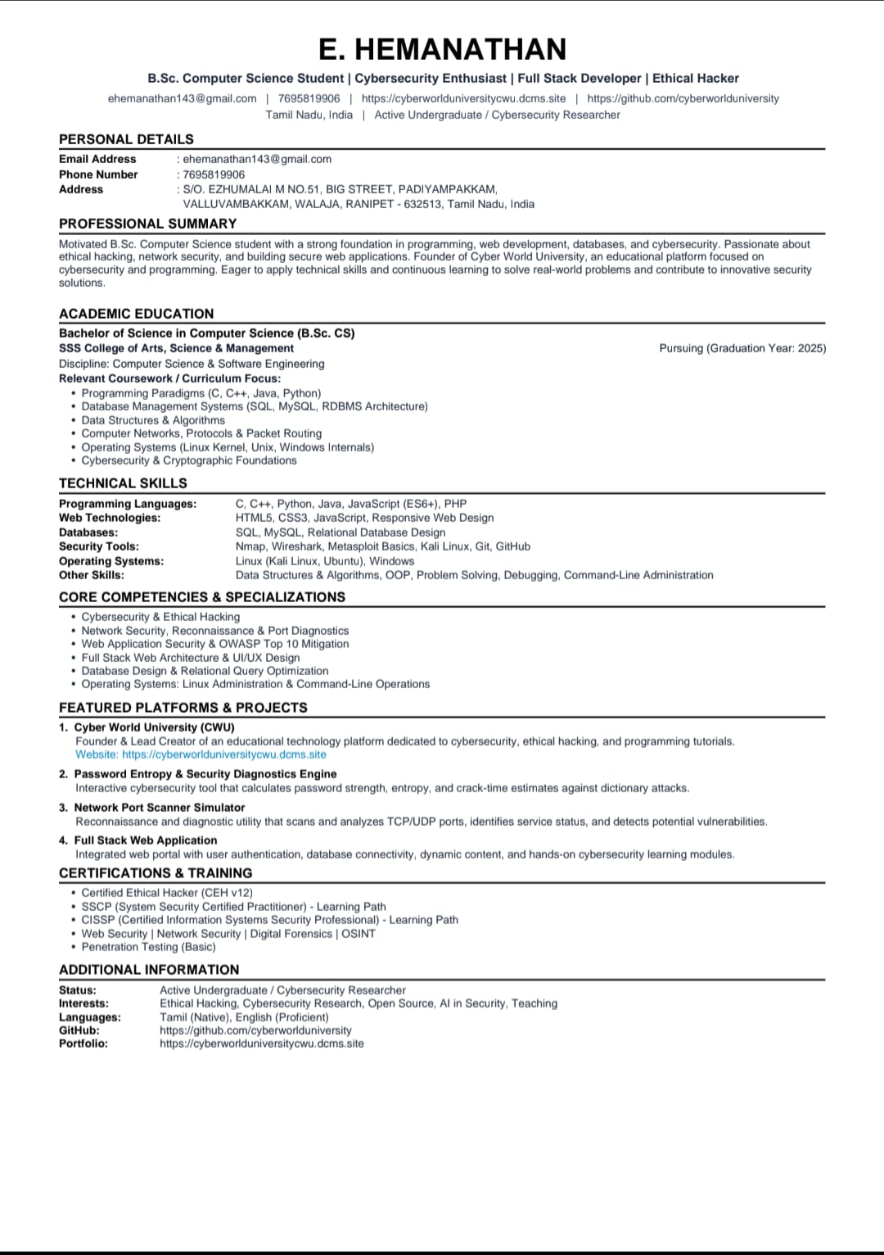

ATS CHECKER:-

ATS means Applicant Tracking System.

A basic ATS checker can verify whether important sections are present in the resume.

It can check:

Name

Email

Phone

Summary

Education

Skills

Projects

Certifications

The purpose is to provide basic feedback about resume completeness.

PRINT / PDF FEATURE:-

The application provides a print button

.

When the user clicks:-

Print / Save PDF

the browser's print dialog opens.

The user can select:-

Destination → Save as PDF

and save the resume as a PDF file.

HTML SOURCE CODE:-

Index.html:-

<!DOCTYPE html>
<html lang="en">
<head>
<meta charset="UTF-8">
<meta name="viewport" content="width=device-width, initial-scale=1.0">

<meta name="description"
content="Online Resume Builder for students to create professional resumes">

<title>Online Resume Builder</title>

<!-- CSS File -->
<link rel="stylesheet" href="style.css">
</head>

<body>

<!-- =========================
HEADER
========================== -->
<header class="header">
<div class="container header-content">
<div class="logo">
<span>📄</span>
<h1>Online Resume Builder</h1>
</div>

<p class="header-subtitle">
Create your professional resume easily
</p>

<nav class="top-nav" aria-label="Primary navigation">
<button
type="button"
id="navAtsBtn"
class="nav-btn"
>
ATS Resume Check
</button>
</nav>
</div>
</header>

<!-- =========================
MAIN CONTAINER
========================== -->
<main class="container main-container" id="mainContainer">

<!-- =========================
RESUME FORM
========================== -->
<section class="form-section">

<div class="section-heading">
<h2>Build Your Resume</h2>
<p>Enter your details below to create your professional resume.</p>
</div>

<!-- =========================
PERSONAL DETAILS
========================== -->
<div class="form-card">

<h3>👤 Personal Details</h3>

<div class="form-row">

<div class="form-group">
<label for="fullName">Full Name *</label>
<input
type="text"
id="fullName"
name="fullName"
placeholder="Enter your full name"
required
>
</div>

<div class="form-group">
<label for="jobTitle">Professional Title</label>
<input
type="text"
id="jobTitle"
name="jobTitle"
placeholder="e.g. B.Sc. Computer Science Student"
>
</div>

</div>

<div class="form-row">

<div class="form-group">
<label for="email">Email Address *</label>
<input
type="email"
id="email"
name="email"
placeholder="example@email.com"
required
>
</div>

<div class="form-group">
<label for="phone">Phone Number *</label>
<input
type="tel"
id="phone"
name="phone"
placeholder="+91 XXXXX XXXXX"
required
>
</div>

</div>

<div class="form-group">
<label for="address">Address</label>

<textarea
id="address"
name="address"
rows="3"
placeholder="Enter your address"
></textarea>
</div>

<div class="form-row">

<div class="form-group">
<label for="linkedin">LinkedIn Profile</label>

<input
type="url"
id="linkedin"
name="linkedin"
placeholder="https://linkedin.com/in/yourname"
>
</div>

<div class="form-group">
<label for="github">GitHub Profile</label>

<input
type="url"
id="github"
name="github"
placeholder="https://github.com/yourname"
>
</div>

</div>

<div class="form-group">
<label for="portfolio">Portfolio Website</label>

<input
type="url"
id="portfolio"
name="portfolio"
placeholder="https://yourwebsite.com"
>
</div>

</div>

<!-- =========================
PROFESSIONAL SUMMARY
========================== -->
<div class="form-card">

<h3>📝 Professional Summary</h3>

<div class="form-group">

<label for="summary">
Career Objective / Profile Summary
</label>

<textarea
id="summary"
name="summary"
rows="5"
placeholder="Write a short professional summary about yourself..."
></textarea>

</div>

</div>

<!-- =========================
EDUCATION
========================== -->
<div class="form-card">

<div class="card-header">

<div>
<h3>🎓 Education</h3>
<p>Add your educational qualifications.</p>
</div>

<button
type="button"
class="add-btn"
id="addEducationBtn"
>
+ Add Education
</button>

</div>

<div id="educationContainer">

<!-- Education Entry -->

<div class="dynamic-item education-item">

<div class="item-header">
<h4>Education 1</h4>

<button
type="button"
class="remove-btn"
>
Remove
</button>
</div>

<div class="form-row">

<div class="form-group">

<label>Degree / Course</label>

<input
type="text"
name="degree[]"
placeholder="e.g. B.Sc. Computer Science"
>

</div>

<div class="form-group">

<label>Institution / College</label>

<input
type="text"
name="institution[]"
placeholder="Enter college/university name"
>

</div>

</div>

<div class="form-row">

<div class="form-group">

<label>Department</label>

<input
type="text"
name="department[]"
placeholder="e.g. Computer Science"
>

</div>

<div class="form-group">

<label>Location</label>

<input
type="text"
name="educationLocation[]"
placeholder="City, State"
>

</div>

</div>

<div class="form-row">

<div class="form-group">

<label>Start Year</label>

<input
type="text"
name="educationStart[]"
placeholder="2024"
>

</div>

<div class="form-group">

<label>End Year</label>

<input
type="text"
name="educationEnd[]"
placeholder="2027 / Present"
>

</div>

<div class="form-group">

<label>CGPA / Percentage</label>

<input
type="text"
name="grade[]"
placeholder="e.g. 8.5 CGPA"
>

</div>

</div>

</div>

</div>

</div>

<!-- =========================
SKILLS
========================== -->
<div class="form-card">

<h3>💻 Skills</h3>

<p class="form-help">
Enter your skills separated by commas.
</p>

<div class="form-group">

<label for="technicalSkills">
Technical Skills
</label>

<input
type="text"
id="technicalSkills"
name="technicalSkills"
placeholder="HTML, CSS, JavaScript, Python, Java, SQL"
>

</div>

<div class="form-group">

<label for="softSkills">
Soft Skills
</label>

<input
type="text"
id="softSkills"
name="softSkills"
placeholder="Communication, Teamwork, Leadership"
>

</div>

<div class="form-group">

<label for="tools">
Tools & Technologies
</label>

<input
type="text"
id="tools"
name="tools"
placeholder="Git, GitHub, VS Code, Linux"
>

</div>

</div>

<!-- =========================
PROJECTS
========================== -->
<div class="form-card">

<div class="card-header">

<div>
<h3>📁 Projects</h3>
<p>Add your academic or personal projects.</p>
</div>

<button
type="button"
class="add-btn"
id="addProjectBtn"
>
+ Add Project
</button>

</div>

<div id="projectsContainer">

<!-- Project Entry -->

<div class="dynamic-item project-item">

<div class="item-header">

<h4>Project 1</h4>

<button
type="button"
class="remove-btn"
>
Remove
</button>

</div>

<div class="form-group">

<label>Project Title</label>

<input
type="text"
name="projectTitle[]"
placeholder="e.g. Online Resume Builder"
>

</div>

<div class="form-row">

<div class="form-group">

<label>Technologies Used</label>

<input
type="text"
name="projectTechnology[]"
placeholder="HTML, CSS, JavaScript"
>

</div>

<div class="form-group">

<label>Project Link</label>

<input
type="url"
name="projectLink[]"
placeholder="https://github.com/..."
>

</div>

</div>

<div class="form-group">

<label>Project Description</label>

<textarea
name="projectDescription[]"
rows="4"
placeholder="Describe your project, your role, and the main features..."
></textarea>

</div>

</div>

</div>

</div>

<!-- =========================
CERTIFICATIONS
========================== -->
<div class="form-card">

<div class="card-header">

<div>
<h3>📜 Certifications</h3>
<p>Add your certifications and achievements.</p>
</div>

<button
type="button"
class="add-btn"
id="addCertificationBtn"
>
+ Add Certification
</button>

</div>

<div id="certificationsContainer">

<!-- Certification Entry -->

<div class="dynamic-item certification-item">

<div class="item-header">

<h4>Certification 1</h4>

<button
type="button"
class="remove-btn"
>
Remove
</button>

</div>

<div class="form-row">

<div class="form-group">

<label>Certification Name</label>

<input
type="text"
name="certificationName[]"
placeholder="e.g. Certified Ethical Hacker"
>

</div>

<div class="form-group">

<label>Issuing Organization</label>

<input
type="text"
name="certificationOrganization[]"
placeholder="e.g. EC-Council"
>

</div>

</div>

<div class="form-row">

<div class="form-group">

<label>Issue Year</label>

<input
type="text"
name="certificationYear[]"
placeholder="2026"
>

</div>

<div class="form-group">

<label>Credential ID</label>

<input
type="text"
name="credentialId[]"
placeholder="Optional"
>

</div>

</div>

<div class="form-group">

<label>Credential / Certificate Link</label>

<input
type="url"
name="certificateLink[]"
placeholder="https://..."
>

</div>

</div>

</div>

</div>

<!-- =========================
ACHIEVEMENTS
========================== -->
<div class="form-card">

<h3>🏆 Achievements</h3>

<div class="form-group">

<label for="achievements">
Achievements / Awards
</label>

<textarea
id="achievements"
name="achievements"
rows="5"
placeholder="Enter your achievements, awards, competitions, workshops, etc."
></textarea>

</div>

</div>

<!-- =========================
LANGUAGES
========================== -->
<div class="form-card">

<h3>🌐 Languages</h3>

<div class="form-group">

<label for="languages">
Languages Known
</label>

<input
type="text"
id="languages"
name="languages"
placeholder="Tamil, English, Hindi"
>

</div>

</div>

<!-- =========================
FORM BUTTONS
========================== -->
<div class="action-buttons">

<button
type="button"
id="generateResumeBtn"
class="primary-btn"
>
Next: Resume Preview →
</button>

<button
type="reset"
id="resetBtn"
class="secondary-btn"
>
🔄 Reset Form
</button>

</div>

</section>

<!-- =========================
RESUME PREVIEW
========================== -->
<section class="preview-section">

<div class="preview-header">

<div>
<h2>Resume Preview</h2>

<p>
Your professional resume will appear here.
</p>
</div>

<div class="preview-actions">
<button
type="button"
id="backToEditorBtn"
class="back-btn"
>
← Back to Edit
</button>

<button
type="button"
id="atsCheckBtn"
class="ats-btn"
>
✓ ATS Check
</button>

<button
type="button"
id="downloadResumeBtn"
class="download-btn"
aria-label="Download resume as PDF"
title="Download resume as PDF"
>
↓ Download PDF
</button>

<button
type="button"
id="printResumeBtn"
class="print-btn"
>
🖨️ Print / Save PDF
</button>
</div>

</div>

<div
id="atsResult"
class="ats-result"
role="status"
aria-live="polite"
hidden
></div>

<div class="upload-checker" id="uploadChecker">
<button
type="button"
id="backFromAtsBtn"
class="back-btn"
>
← Back to Resume Builder
</button>

<div>
<h3>Check an existing resume</h3>
<p>Upload a text-based resume file to scan it for ATS basics.</p>
</div>

<div class="upload-controls">
<label class="file-picker" for="resumeFile">
Choose resume file
<input
type="file"
id="resumeFile"
accept=".txt,.md,.html,text/plain,text/markdown,text/html"
>
</label>

<button
type="button"
id="uploadCheckBtn"
class="upload-check-btn"
>
Check upload
</button>

<button
type="button"
id="removeResumeFileBtn"
class="remove-file-btn"
hidden
>
Remove file
</button>
</div>

<p id="uploadFileName" class="upload-file-name">No file selected</p>
<div id="uploadResult" class="upload-result" role="status" aria-live="polite" hidden></div>
</div>

<!-- =========================
RESUME DOCUMENT
========================== -->
<div id="resumePreview" class="resume-preview">

<!-- Resume Header -->

<div class="resume-header">

<h1 id="previewName">
Your Name
</h1>

<h2 id="previewJobTitle">
Professional Title
</h2>

<div class="contact-info">

<span id="previewEmail">
email@example.com
</span>

<span id="previewPhone">
+91 XXXXX XXXXX
</span>

<span id="previewAddress">
Your Address
</span>

</div>

<div class="profile-links">

<a
id="previewLinkedin"
href="#"
target="_blank"
>
LinkedIn
</a>

<a
id="previewGithub"
href="#"
target="_blank"
>
GitHub
</a>

<a
id="previewPortfolio"
href="#"
target="_blank"
>
Portfolio
</a>

</div>

</div>

<!-- Professional Summary -->

<div
class="resume-section"
id="previewSummarySection"
>

<h3>PROFILE</h3>

<p id="previewSummary">
Your professional summary will appear here.
</p>

</div>

<!-- Education -->

<div
class="resume-section"
id="previewEducationSection"
>

<h3>EDUCATION</h3>

<div id="previewEducation">

<div class="preview-placeholder">
Education details will appear here.
</div>

</div>

</div>

<!-- Skills -->

<div
class="resume-section"
id="previewSkillsSection"
>

<h3>SKILLS</h3>

<div class="skills-preview">

<div>
<strong>Technical Skills:</strong>

<span id="previewTechnicalSkills">
-
</span>
</div>

<div>
<strong>Soft Skills:</strong>

<span id="previewSoftSkills">
-
</span>
</div>

<div>
<strong>Tools:</strong>

<span id="previewTools">
-
</span>
</div>

</div>

</div>

<!-- Projects -->

<div
class="resume-section"
id="previewProjectsSection"
>

<h3>PROJECTS</h3>

<div id="previewProjects">

<div class="preview-placeholder">
Your projects will appear here.
</div>

</div>

</div>

<!-- Certifications -->

<div
class="resume-section"
id="previewCertificationsSection"
>

<h3>CERTIFICATIONS</h3>

<div id="previewCertifications">

<div class="preview-placeholder">
Your certifications will appear here.
</div>

</div>

</div>

<!-- Achievements -->

<div
class="resume-section"
id="previewAchievementsSection"
>

<h3>ACHIEVEMENTS</h3>

<p id="previewAchievements">
-
</p>

</div>

<!-- Languages -->

<div
class="resume-section"
id="previewLanguagesSection"
>

<h3>LANGUAGES</h3>

<p id="previewLanguages">
-
</p>

</div>

</div>

</section>

</main>

<!-- =========================
FOOTER
========================== -->
<footer class="footer">

<div class="container">

<p>
© 2026 Online Resume Builder.
Designed for students and job seekers E HEMANATHAN.
</p>

</div>

</footer>

<!-- JavaScript File -->
<script src="script.js"></script>

</body>

</html></html>

CSS SOURCE CODE:-

Style.css:-

/* =========================================================

ONLINE RESUME BUILDER

Professional College Project CSS

========================================================= */

/* =========================================================

1. GLOBAL SETTINGS

========================================================= */

* {

margin: 0;

padding: 0;

box-sizing: border-box;

}

html {

scroll-behavior: smooth;

}

body {

font-family: "Segoe UI", Arial, Helvetica, sans-serif;

background: #f3f6fb;

color: #1f2937;

line-height: 1.6;

}

/* =========================================================

2. COMMON CONTAINER

========================================================= */

.container {

width: 92%;

max-width: 1500px;

margin: auto;

}

/* =========================================================

3. HEADER

========================================================= */

.header {

background: linear-gradient(135deg, #172554, #2563eb);

color: white;

padding: 25px 0;

box-shadow: 0 4px 15px rgba(0, 0, 0, 0.12);

}

.header-content {

display: flex;

align-items: center;

justify-content: space-between;

gap: 20px;

}

.logo {

display: flex;

align-items: center;

gap: 12px;

}

.logo span {

font-size: 32px;

}

.logo h1 {

font-size: 25px;

font-weight: 700;

}

.header-subtitle {

font-size: 15px;

opacity: 0.9;

}

/* =========================================================

4. MAIN LAYOUT

========================================================= */

.main-container {

display: grid;

grid-template-columns: minmax(400px, 1fr) minmax(500px, 1.1fr);

gap: 30px;

align-items: start;

padding: 35px 0 50px;

}

.main-container:not(.preview-only) .preview-section {

display: none;

}

.main-container:not(.preview-only):not(.ats-only) {

display: block;

max-width: 1000px;

}

.main-container:not(.preview-only):not(.ats-only) .form-section {

max-width: 900px;

margin: 0 auto;

}

.main-container.preview-only {

display: block;

max-width: 1000px;

}

.main-container.preview-only .form-section {

display: none;

}

.main-container.preview-only .preview-section {

display: flex;

position: static;

}

.main-container.preview-only .upload-checker {

display: none !important;

}

.main-container.ats-only {

display: block;

max-width: 760px;

}

.main-container.ats-only .form-section,

.main-container.ats-only .preview-header,

.main-container.ats-only .resume-preview,

.main-container.ats-only .ats-result {

display: none !important;

}

.main-container.ats-only .preview-header::after {

display: none;

}

.main-container.ats-only .preview-section {

display: block;

position: static;

}

.main-container.ats-only .upload-checker {

margin-top: 20px;

text-align: center;

}

.main-container.ats-only .upload-checker > .back-btn {

display: inline-flex;

}

.main-container.ats-only .upload-controls {

justify-content: center;

}

.main-container.ats-only .upload-result {

align-items: center;

text-align: center;

}

.main-container.ats-only .upload-file-name {

text-align: center;

}

/* =========================================================

5. FORM SECTION

========================================================= */

.form-section {

min-width: 0;

}

.section-heading {

margin-bottom: 20px;

}

.section-heading h2 {

color: #172554;

font-size: 27px;

margin-bottom: 5px;

}

.section-heading p {

color: #64748b;

font-size: 14px;

}

/* =========================================================

6. FORM CARDS

========================================================= */

.form-card {

background: white;

border-radius: 12px;

padding: 24px;

margin-bottom: 20px;

border: 1px solid #e2e8f0;

box-shadow: 0 5px 18px rgba(15, 23, 42, 0.06);

}

.form-card h3 {

color: #172554;

font-size: 20px;

margin-bottom: 7px;

}

.form-card > p {

color: #64748b;

font-size: 13px;

}

.card-header {

display: flex;

justify-content: space-between;

align-items: center;

gap: 15px;

margin-bottom: 20px;

}

.card-header h3 {

margin-bottom: 2px;

}

.card-header p {

color: #64748b;

font-size: 13px;

}

/* =========================================================

7. FORM ROWS

========================================================= */

.form-row {

display: grid;

grid-template-columns: repeat(2, 1fr);

gap: 16px;

margin-bottom: 16px;

}

.form-row:last-child {

margin-bottom: 0;

}

/* Three-column row */

.form-row:has(.form-group:nth-child(3)) {

grid-template-columns: repeat(3, 1fr);

}

/* =========================================================

8. FORM GROUP

========================================================= */

.form-group {

margin-bottom: 16px;

}

.form-group:last-child {

margin-bottom: 0;

}

.form-group label {

display: block;

margin-bottom: 7px;

font-size: 14px;

font-weight: 600;

color: #334155;

}

/* =========================================================

9. INPUTS

========================================================= */

input,

textarea,

select {

width: 100%;

padding: 12px 14px;

border: 1px solid #cbd5e1;

border-radius: 8px;

background: #ffffff;

color: #1e293b;

font-family: inherit;

font-size: 14px;

outline: none;

transition: 0.25s ease;

}

input {

height: 45px;

}

textarea {

min-height: 100px;

resize: vertical;

}

input::placeholder,

textarea::placeholder {

color: #94a3b8;

}

input:focus,

textarea:focus,

select:focus {

border-color: #2563eb;

box-shadow: 0 0 0 3px rgba(37, 99, 235, 0.12);

}

/* =========================================================

10. FORM HELP

========================================================= */

.form-help {

margin-bottom: 14px;

color: #64748b;

font-size: 13px;

}

/* =========================================================

11. DYNAMIC ITEMS

========================================================= */

.dynamic-item {

background: #f8fafc;

border: 1px solid #dbe3ef;

border-radius: 10px;

padding: 18px;

margin-bottom: 16px;

}

.dynamic-item:last-child {

margin-bottom: 0;

}

.item-header {

display: flex;

justify-content: space-between;

align-items: center;

gap: 15px;

margin-bottom: 18px;

}

.item-header h4 {

color: #1e3a8a;

font-size: 16px;

}

/* =========================================================

12. ADD BUTTON

========================================================= */

.add-btn {

border: none;

background: #2563eb;

color: white;

padding: 9px 14px;

border-radius: 7px;

font-size: 13px;

font-weight: 600;

cursor: pointer;

white-space: nowrap;

transition: 0.2s ease;

}

.add-btn:hover {

background: #1d4ed8;

transform: translateY(-1px);

}

/* =========================================================

13. REMOVE BUTTON

========================================================= */

.remove-btn {

border: 1px solid #fecaca;

background: #fff1f2;

color: #dc2626;

padding: 7px 11px;

border-radius: 6px;

font-size: 12px;

font-weight: 600;

cursor: pointer;

transition: 0.2s ease;

}

.remove-btn:hover {

background: #fee2e2;

}

/* =========================================================

14. ACTION BUTTONS

========================================================= */

.action-buttons {

display: flex;

gap: 12px;

margin-top: 10px;

margin-bottom: 20px;

}

.primary-btn,

.secondary-btn,

.print-btn {

border: none;

border-radius: 8px;

padding: 13px 20px;

font-family: inherit;

font-size: 14px;

font-weight: 600;

cursor: pointer;

transition: 0.2s ease;

}

.primary-btn {

flex: 1;

background: #2563eb;

color: white;

}

.primary-btn:hover {

background: #1d4ed8;

transform: translateY(-1px);

}

.secondary-btn {

background: #e2e8f0;

color: #334155;

}

.secondary-btn:hover {

background: #cbd5e1;

}

/* =========================================================

15. PREVIEW SECTION

========================================================= */

.preview-section {

min-width: 0;

position: sticky;

top: 20px;

}

.preview-header {

display: flex;

justify-content: space-between;

align-items: center;

gap: 15px;

margin-bottom: 18px;

}

.preview-header h2 {

color: #172554;

font-size: 25px;

margin-bottom: 3px;

}

.preview-header p {

color: #64748b;

font-size: 13px;

}

/* =========================================================

16. PRINT BUTTON

========================================================= */

.print-btn {

background: #0f172a;

color: white;

white-space: nowrap;

}

.print-btn:hover {

background: #1e293b;

transform: translateY(-1px);

}

/* =========================================================

17. RESUME PREVIEW

========================================================= */

.resume-preview {

width: 100%;

max-width: 850px;

min-height: 1100px;

margin: 0 auto;

padding: 55px 60px;

background: white;

border: 1px solid #dbe3ef;

box-shadow: 0 10px 35px rgba(15, 23, 42, 0.12);

color: #1f2937;

}

/* =========================================================

18. RESUME HEADER

========================================================= */

.resume-header {

text-align: center;

padding-bottom: 22px;

border-bottom: 2px solid #172554;

}

.resume-header h1 {

color: #172554;

font-size: 34px;

line-height: 1.2;

margin-bottom: 6px;

text-transform: uppercase;

letter-spacing: 0.5px;

}

.resume-header h2 {

color: #475569;

font-size: 17px;

font-weight: 500;

margin-bottom: 14px;

}

.contact-info {

display: flex;

justify-content: center;

flex-wrap: wrap;

gap: 8px 18px;

color: #475569;

font-size: 12px;

}

.contact-info span:not(:last-child)::after {

content: "•";

margin-left: 18px;

color: #94a3b8;

}

.profile-links {

display: flex;

justify-content: center;

flex-wrap: wrap;

gap: 15px;

margin-top: 8px;

}

.profile-links a {

color: #2563eb;

font-size: 12px;

text-decoration: none;

}

.profile-links a:hover {

text-decoration: underline;

}

/* =========================================================

19. RESUME SECTIONS

========================================================= */

.resume-section {

margin-top: 24px;

}

.resume-section h3 {

color: #172554;

font-size: 15px;

letter-spacing: 1.2px;

border-bottom: 1px solid #cbd5e1;

padding-bottom: 5px;

margin-bottom: 12px;

}

.resume-section p {

color: #374151;

font-size: 13px;

line-height: 1.7;

}

/* =========================================================

20. EDUCATION PREVIEW

========================================================= */

.education-preview-item {

margin-bottom: 16px;

}

.education-preview-item:last-child {

margin-bottom: 0;

}

.education-preview-item h4 {

color: #1e293b;

font-size: 14px;

margin-bottom: 2px;

}

.education-preview-item .institution {

color: #475569;

font-size: 13px;

font-weight: 600;

}

.education-preview-item .education-details {

color: #64748b;

font-size: 12px;

margin-top: 3px;

}

/* =========================================================

21. SKILLS PREVIEW

========================================================= */

.skills-preview {

display: flex;

flex-direction: column;

gap: 7px;

}

.skills-preview div {

font-size: 13px;

color: #374151;

}

.skills-preview strong {

color: #1e293b;

}

/* =========================================================

22. PROJECT PREVIEW

========================================================= */

.project-preview-item {

margin-bottom: 17px;

}

.project-preview-item:last-child {

margin-bottom: 0;

}

.project-preview-item h4 {

color: #1e293b;

font-size: 14px;

margin-bottom: 3px;

}

.project-preview-item .project-tech {

color: #2563eb;

font-size: 12px;

font-weight: 600;

margin-bottom: 4px;

}

.project-preview-item p {

font-size: 12px;

line-height: 1.6;

}

.project-preview-item a {

color: #2563eb;

font-size: 11px;

text-decoration: none;

}

.project-preview-item a:hover {

text-decoration: underline;

}

/* =========================================================

23. CERTIFICATION PREVIEW

========================================================= */

.certification-preview-item {

margin-bottom: 13px;

}

.certification-preview-item:last-child {

margin-bottom: 0;

}

.certification-preview-item h4 {

color: #1e293b;

font-size: 14px;

margin-bottom: 2px;

}

.certification-preview-item p {

color: #64748b;

font-size: 12px;

}

/* =========================================================

24. PLACEHOLDER

========================================================= */

.preview-placeholder {

color: #94a3b8;

font-size: 12px;

font-style: italic;

padding: 5px 0;

}

/* =========================================================

25. FOOTER

========================================================= */

.footer {

background: #172554;

color: white;

text-align: center;

padding: 20px;

}

.footer p {

font-size: 13px;

opacity: 0.85;

}

/* =========================================================

26. SCROLLBAR

========================================================= */

::-webkit-scrollbar {

width: 9px;

}

::-webkit-scrollbar-track {

background: #e2e8f0;

}

::-webkit-scrollbar-thumb {

background: #94a3b8;

border-radius: 10px;

}

::-webkit-scrollbar-thumb:hover {

background: #64748b;

}

/* =========================================================

27. TABLET RESPONSIVE DESIGN

========================================================= */

@media (max-width: 1100px) {

.main-container {

grid-template-columns: 1fr;

}

.preview-section {

position: static;

}

.resume-preview {

max-width: 850px;

}

.form-row:has(.form-group:nth-child(3)) {

grid-template-columns: repeat(3, 1fr);

}

}

/* =========================================================

28. MOBILE RESPONSIVE DESIGN

========================================================= */

@media (max-width: 700px) {

.container {

width: 94%;

}

.header {

padding: 20px 0;

}

.header-content {

flex-direction: column;

text-align: center;

}

.logo h1 {

font-size: 21px;

}

.header-subtitle {

font-size: 13px;

}

.main-container {

padding-top: 22px;

gap: 20px;

}

.form-card {

padding: 18px;

}

.section-heading h2 {

font-size: 23px;

}

.form-row,

.form-row:has(.form-group:nth-child(3)) {

grid-template-columns: 1fr;

gap: 0;

}

.card-header {

align-items: flex-start;

flex-direction: column;

}

.add-btn {

width: 100%;

}

.action-buttons {

flex-direction: column;

}

.primary-btn,

.secondary-btn {

width: 100%;

}

.preview-header {

flex-direction: column;

align-items: stretch;

}

.print-btn {

width: 100%;

}

.resume-preview {

padding: 35px 25px;

min-height: auto;

}

.resume-header h1 {

font-size: 26px;

}

.resume-header h2 {

font-size: 15px;

}

.contact-info {

flex-direction: column;

gap: 4px;

}

.contact-info span::after {

display: none !important;

}

.profile-links {

flex-direction: column;

gap: 5px;

}

.item-header {

align-items: flex-start;

}

.remove-btn {

flex-shrink: 0;

}

}

/* =========================================================

29. SMALL MOBILE DEVICES

========================================================= */

@media (max-width: 420px) {

.container {

width: 95%;

}

.form-card {

padding: 15px;

}

.resume-preview {

padding: 25px 18px;

}

.resume-header h1 {

font-size: 22px;

}

.resume-section h3 {

font-size: 13px;

}

input,

textarea {

font-size: 13px;

}

}

/* =========================================================

30. MODERN UI REFRESH

========================================================= */

:root {

--ink: #18221f;

--muted: #6d7974;

--canvas: #edf3fc;

--surface: #ffffff;

--line: #dce4de;

--accent: #2f6fed;

--accent-dark: #1f54b5;

--deep: #102a56;

--soft: #f4f7fd;

}

body {

background:

radial-gradient(circle at 10% 0%, rgba(47, 111, 237, 0.12), transparent 24rem),

linear-gradient(135deg, #f7faff 0%, var(--canvas) 55%, #e8effc 100%);

color: var(--ink);

font-family: "Trebuchet MS", "Segoe UI", sans-serif;

}

button {

min-height: 44px;

text-align: center;

line-height: 1.2;

}

.header {

background: var(--deep);

padding: 28px 0 30px;

border-bottom: 4px solid var(--accent);

box-shadow: 0 12px 30px rgba(16, 42, 86, 0.16);

}

.logo {

gap: 13px;

}

.logo span {

display: grid;

width: 43px;

height: 43px;

place-items: center;

border-radius: 12px;

background: var(--accent);

font-size: 24px;

}

.logo h1 {

font-size: 24px;

letter-spacing: 0.2px;

}

.header-subtitle {

color: #d6e0da;

}

.top-nav {

display: flex;

align-items: center;

}

.nav-btn {

min-height: 44px;

border: 1px solid rgba(255, 255, 255, 0.35);

border-radius: 10px;

padding: 0 16px;

background: rgba(255, 255, 255, 0.08);

color: white;

font: inherit;

font-size: 13px;

font-weight: 700;

cursor: pointer;

transition: 180ms ease;

}

.nav-btn:hover {

border-color: #8eb4ff;

background: rgba(47, 111, 237, 0.3);

transform: translateY(-1px);

}

.account-area {

display: flex;

align-items: center;

gap: 12px;

color: #d6e0da;

font-size: 12px;

}

.account-btn,

.logout-btn {

border: 1px solid rgba(255, 255, 255, 0.28);

border-radius: 9px;

padding: 9px 14px;

background: transparent;

color: white;

font: inherit;

font-weight: 700;

cursor: pointer;

transition: 180ms ease;

}

.account-btn:hover,

.logout-btn:hover {

border-color: var(--accent);

background: rgba(47, 111, 237, 0.18);

}

.auth-dialog {

width: min(92vw, 410px);

padding: 0;

border: 0;

border-radius: 18px;

color: var(--ink);

box-shadow: 0 24px 80px rgba(24, 34, 31, 0.28);

}

.auth-dialog::backdrop {

background: rgba(24, 34, 31, 0.52);

backdrop-filter: blur(4px);

}

.auth-dialog form {

position: relative;

display: grid;

gap: 10px;

padding: 32px;

}

.dialog-kicker {

margin: 0;

color: var(--accent-dark);

font-size: 12px;

font-weight: 800;

letter-spacing: 1.2px;

text-transform: uppercase;

}

.auth-dialog h2 {

margin: 0 0 4px;

color: var(--deep);

font-size: 28px;

}

.auth-message {

margin: 0 0 12px;

color: var(--muted);

font-size: 13px;

}

.auth-message.is-error {

color: #b4422c;

}

.auth-dialog label {

color: #405049;

font-size: 13px;

font-weight: 700;

}

.auth-dialog input {

margin-bottom: 7px;

}

.dialog-close {

position: absolute;

top: 16px;

right: 18px;

border: 0;

background: transparent;

color: var(--muted);

font-size: 26px;

line-height: 1;

cursor: pointer;

}

.auth-switch {

border: 0;

background: transparent;

color: var(--accent-dark);

font: inherit;

font-size: 13px;

font-weight: 700;

cursor: pointer;

}

.main-container {

grid-template-columns: minmax(390px, 0.9fr) minmax(520px, 1.1fr);

gap: 34px;

padding: 42px 0 60px;

}

.section-heading {

margin-bottom: 24px;

position: relative;

padding-left: 18px;

}

.section-heading::before {

position: absolute;

top: 6px;

bottom: 4px;

left: 0;

width: 4px;

border-radius: 4px;

background: var(--accent);

content: "";

transform-origin: top;

animation: grow-line 700ms 180ms ease-out both;

}

.section-heading h2,

.preview-header h2 {

color: var(--deep);

letter-spacing: -0.5px;

}

.section-heading p,

.preview-header p {

color: var(--muted);

}

.preview-header::after {

display: inline-flex;

align-items: center;

justify-content: center;

align-self: center;

min-height: 44px;

box-sizing: border-box;

border: 1px solid #b9d0fa;

border-radius: 10px;

padding: 0 15px;

background: #eef4ff;

color: var(--accent-dark);

content: "LIVE PREVIEW";

font-size: 10px;

font-weight: 800;

letter-spacing: 0.8px;

text-align: center;

animation: status-blink 2.8s ease-in-out infinite;

}

.form-card {

border: 1px solid rgba(220, 228, 222, 0.95);

border-radius: 16px;

padding: 25px;

margin-bottom: 18px;

box-shadow: 0 10px 26px rgba(16, 42, 86, 0.055);

transition: border-color 180ms ease, box-shadow 180ms ease, transform 180ms ease;

}

.form-card:hover {

border-color: #c9d9ce;

box-shadow: 0 14px 30px rgba(16, 42, 86, 0.09);

transform: translateY(-2px);

}

.form-card h3 {

color: var(--deep);

}

.form-card > p,

.card-header p {

color: var(--muted);

}

.form-group label {

color: #405049;

font-size: 13px;

letter-spacing: 0.15px;

}

input,

textarea,

select {

border-color: #d4ded7;

border-radius: 10px;

background: #fbfcfb;

color: var(--ink);

}

input:focus,

textarea:focus,

select:focus {

border-color: var(--accent);

box-shadow: 0 0 0 4px rgba(47, 111, 237, 0.14);

background: white;

}

.dynamic-item {

background: var(--soft);

border-color: #dce5de;

border-radius: 12px;

transition: border-color 180ms ease, background 180ms ease;

}

.dynamic-item:focus-within {

border-color: rgba(47, 111, 237, 0.55);

background: #fffaf7;

}

.item-header h4 {

color: var(--deep);

}

.add-btn,

.primary-btn {

background: var(--accent);

}

.add-btn,

.primary-btn,

.print-btn {

position: relative;

overflow: hidden;

}

.add-btn::after,

.primary-btn::after,

.print-btn::after {

position: absolute;

top: 0;

left: -75%;

width: 42%;

height: 100%;

background: linear-gradient(100deg, transparent, rgba(255, 255, 255, 0.24), transparent);

content: "";

transform: skewX(-18deg);

}

.add-btn:hover::after,

.primary-btn:hover::after,

.print-btn:hover::after {

animation: button-sheen 650ms ease-out;

}

.add-btn:hover,

.primary-btn:hover {

background: var(--accent-dark);

}

.remove-btn {

border-color: #f1c8ba;

background: #fff8f5;

color: var(--accent-dark);

}

.remove-btn:hover {

background: #ffede6;

}

.secondary-btn {

background: #e0e8e2;

color: var(--deep);

}

.secondary-btn:hover {

background: #d2ded5;

}

.preview-section {

top: 28px;

display: flex;

flex-direction: column;

align-items: stretch;

}

.preview-actions {

display: flex;

align-items: center;

gap: 9px;

}

.ats-btn {

border: 1px solid #b9d0fa;

border-radius: 10px;

padding: 13px 15px;

background: #eef4ff;

color: var(--accent-dark);

font: inherit;

font-size: 14px;

font-weight: 700;

height: 44px;

white-space: nowrap;

cursor: pointer;

transition: 180ms ease;

}

.ats-btn:hover {

border-color: var(--accent);

background: #e2ecff;

transform: translateY(-1px);

}

.ats-result {

margin: 0 0 18px;

padding: 16px 18px;

border: 1px solid #cbd9ee;

border-left: 4px solid var(--accent);

border-radius: 12px;

background: #f7faff;

color: #42536d;

font-size: 13px;

animation: rise-in 350ms ease-out both;

}

.ats-result p {

margin: 5px 0 0;

}

.ats-score {

display: flex;

align-items: baseline;

justify-content: space-between;

color: var(--deep);

font-size: 14px;

font-weight: 700;

}

.ats-score strong {

color: var(--accent-dark);

font-size: 24px;

}

.ats-result ul {

display: flex;

flex-wrap: wrap;

gap: 6px 20px;

margin: 10px 0 0;

padding-left: 18px;

}

.ats-result.is-good {

border-left-color: #2f8a5a;

background: #f2fbf5;

}

.ats-result.is-good .ats-score strong,

.ats-success {

color: #267346;

}

.ats-result.is-medium {

border-left-color: #d49b28;

background: #fffaf0;

}

.ats-result.is-medium .ats-score strong {

color: #a66d08;

}

.ats-result.is-low {

border-left-color: #c45151;

background: #fff7f7;

}

.ats-result.is-low .ats-score strong {

color: #ad3838;

}

.upload-checker {

margin: 0 0 20px;

padding: 18px;

border: 1px solid #d6e1f2;

border-radius: 14px;

background: rgba(255, 255, 255, 0.7);

}

.upload-checker > .back-btn {

margin-bottom: 18px;

}

.upload-checker h3 {

margin: 0 0 4px;

color: var(--deep);

font-size: 16px;

}

.upload-checker p {

margin: 0;

color: var(--muted);

font-size: 12px;

}

.upload-controls {

display: flex;

align-items: center;

gap: 9px;

margin-top: 14px;

}

.file-picker,

.upload-check-btn {

border: 1px solid #c9d8f4;

border-radius: 9px;

padding: 10px 13px;

background: #f3f7ff;

color: var(--accent-dark);

font-size: 12px;

font-weight: 700;

cursor: pointer;

transition: 180ms ease;

}

.file-picker:hover,

.upload-check-btn:hover {

border-color: var(--accent);

background: #e6efff;

}

.file-picker input {

display: none;

}

.upload-check-btn {

background: var(--accent);

color: white;

}

.upload-check-btn:hover {

background: var(--accent-dark);

color: white;

}

.remove-file-btn {

border: 1px solid #f0c8c8;

border-radius: 9px;

padding: 10px 13px;

background: #fff7f7;

color: #ad3838;

font-size: 12px;

font-weight: 700;

cursor: pointer;

transition: 180ms ease;

}

.remove-file-btn:hover {

background: #ffeded;

}

.upload-file-name {

overflow: hidden;

margin-top: 9px !important;

text-overflow: ellipsis;

white-space: nowrap;

}

.upload-result {

display: flex;

flex-direction: column;

gap: 4px;

margin-top: 12px;

padding: 11px 13px;

border-radius: 9px;

background: #f7faff;

color: #42536d;

font-size: 12px;

}

.upload-result:not([hidden]),

.ats-result:not([hidden]) {

animation: result-pop 380ms cubic-bezier(0.22, 1, 0.36, 1) both;

}

.upload-result strong {

color: var(--deep);

font-size: 14px;

}

.upload-result.is-good {

background: #f2fbf5;

}

.upload-result.is-good strong {

color: #267346;

}

.upload-result.is-warning {

background: #fffaf0;

}

.upload-result.is-warning strong {

color: #a66d08;

}

.upload-result.is-low {

background: #fff7f7;

}

.upload-result.is-low strong {

color: #ad3838;

}

.download-btn {

border: 1px solid #c9d8f4;

border-radius: 10px;

padding: 13px 16px;

background: #f3f7ff;

.upload-controls {

align-items: stretch;

flex-direction: column;

}

.file-picker,

.upload-check-btn {

text-align: center;

}

color: var(--accent-dark);

font: inherit;

font-size: 14px;

font-weight: 700;

height: 44px;

white-space: nowrap;

cursor: pointer;

transition: 180ms ease;

}

.download-btn:hover {

border-color: var(--accent);

background: #e6efff;

transform: translateY(-1px);

}

.print-btn {

display: inline-flex;

align-items: center;

justify-content: center;

background: var(--deep);

border-radius: 10px;

height: 44px;

white-space: nowrap;

text-align: center;

}

.print-btn:hover {

background: #29483f;

}

.resume-preview {

align-self: center;

border: none;

border-top: 6px solid var(--accent);

border-radius: 4px;

box-shadow: 0 18px 42px rgba(16, 42, 86, 0.14);

}

.resume-header {

border-bottom-color: var(--deep);

}

.resume-header h1,

.resume-section h3 {

color: var(--deep);

}

.profile-links a,

.project-preview-item .project-tech,

.project-preview-item a {

color: var(--accent-dark);

}

.footer {

background: var(--deep);

}

@keyframes rise-in {

from {

opacity: 0;

transform: translateY(18px);

}

to {

opacity: 1;

transform: translateY(0);

}

}

.back-btn {

display: inline-flex;

align-items: center;

justify-content: center;

height: 44px;

min-height: 44px;

width: 220px;

min-width: 220px;

box-sizing: border-box;

border: 1px solid #c9d8f4;

border-radius: 10px;

padding: 13px 15px;

background: #f3f7ff;

color: var(--accent-dark);

font: inherit;

font-size: 14px;

font-weight: 700;

white-space: nowrap;

text-align: center;

cursor: pointer;

transition: 180ms ease;

}

.back-btn:hover {

border-color: var(--accent);

background: #e6efff;

transform: translateY(-1px);

}

@keyframes soft-float {

0%,

100% {

transform: translateY(0);

}

50% {

transform: translateY(-4px);

}

}

@keyframes grow-line {

from {

opacity: 0;

transform: scaleY(0);

}

to {

opacity: 1;

transform: scaleY(1);

}

}

@keyframes status-blink {

0%,

100% {

box-shadow: 0 0 0 0 rgba(47, 111, 237, 0);

}

50% {

box-shadow: 0 0 0 4px rgba(47, 111, 237, 0.09);

}

}

@keyframes button-sheen {

from {

left: -75%;

}

to {

left: 135%;

}

}

@keyframes result-pop {

from {

opacity: 0;

transform: translateY(8px) scale(0.98);

}

to {

opacity: 1;

transform: translateY(0) scale(1);

}

}

.header {

animation: rise-in 650ms ease-out both;

}

.section-heading,

.preview-header {

animation: rise-in 650ms 100ms ease-out both;

}

.form-card {

animation: rise-in 650ms ease-out both;

}

.form-card:nth-of-type(2) {

animation-delay: 100ms;

}

.form-card:nth-of-type(3) {

animation-delay: 160ms;

}

.form-card:nth-of-type(4) {

animation-delay: 220ms;

}

.form-card:nth-of-type(5) {

animation-delay: 280ms;

}

.form-card:nth-of-type(6) {

animation-delay: 340ms;

}

.resume-preview {

animation: rise-in 700ms 180ms ease-out both;

}

.logo span {

animation: soft-float 4s 900ms ease-in-out infinite;

}

.primary-btn:active,

.print-btn:active,

.add-btn:active,

.secondary-btn:active {

transform: translateY(1px) scale(0.98);

}

@media (prefers-reduced-motion: reduce) {

*,

*::before,

*::after {

animation-duration: 0.01ms !important;

animation-iteration-count: 1 !important;

scroll-behavior: auto !important;

transition-duration: 0.01ms !important;

}

}

@media (max-width: 700px) {

.preview-actions {

width: 100%;

}

.back-btn,

.download-btn,

.ats-btn,

.preview-actions .print-btn {

flex: 1;

}

}

@media (max-width: 760px) {

.preview-actions {

align-items: stretch;

flex-direction: column;

}

.preview-actions button {

width: 100%;

}

}

@media (max-width: 700px) {

.top-nav {

width: 100%;

justify-content: center;

}

.nav-btn {

width: 100%;

}

}

/* =========================================================

31. PRINT / SAVE AS PDF

========================================================= */

@media print {

*,

*::before,

*::after {

animation: none !important;

transition: none !important;

}

@page {

size: A4;

margin: 0;

}

body {

background: white;

}

.header,

.form-section,

.preview-header,

.footer {

display: none !important;

}

.main-container {

display: block;

width: 100%;

margin: 0;

padding: 0;

}

.preview-section {

width: 100%;

position: static;

}

.resume-preview {

width: 210mm;

min-height: 297mm;

max-width: none;

margin: 0;

padding: 18mm;

border: none;

box-shadow: none;

}

.resume-section {

break-inside: avoid;

}

.education-preview-item,

.project-preview-item,

.certification-preview-item {

break-inside: avoid;

}

a {

color: inherit;

text-decoration: none;

}

}

/* =========================================================

31. ACCESSIBILITY

========================================================= */

button:focus-visible,

input:focus-visible,

textarea:focus-visible,

select:focus-visible,

a:focus-visible {

outline: 3px solid rgba(37, 99, 235, 0.35);

outline-offset: 2px;

}

JAVASCRIPT SOURCE CODE:-

script.js:-

/* =========================================================

ONLINE RESUME BUILDER

JavaScript Functionality

========================================================= */

document.addEventListener("DOMContentLoaded", function () {

/* =====================================================

GET ELEMENTS

===================================================== */

const addEducationBtn =

document.getElementById("addEducationBtn");

const addProjectBtn =

document.getElementById("addProjectBtn");

const addCertificationBtn =

document.getElementById("addCertificationBtn");

const generateResumeBtn =

document.getElementById("generateResumeBtn");

const printResumeBtn =

document.getElementById("printResumeBtn");

const downloadResumeBtn =

document.getElementById("downloadResumeBtn");

const atsCheckBtn =

document.getElementById("atsCheckBtn");

const atsResult =

document.getElementById("atsResult");

const resumeFile =

document.getElementById("resumeFile");

const uploadCheckBtn =

document.getElementById("uploadCheckBtn");

const removeResumeFileBtn =

document.getElementById("removeResumeFileBtn");

const uploadFileName =

document.getElementById("uploadFileName");

const uploadResult =

document.getElementById("uploadResult");

const resetBtn =

document.getElementById("resetBtn");

const educationContainer =

document.getElementById("educationContainer");

const projectsContainer =

document.getElementById("projectsContainer");

const certificationsContainer =

document.getElementById("certificationsContainer");

const mainContainer =

document.getElementById("mainContainer");

const backToEditorBtn =

document.getElementById("backToEditorBtn");

const navAtsBtn =

document.getElementById("navAtsBtn");

const uploadChecker =

document.getElementById("uploadChecker");

const backFromAtsBtn =

document.getElementById("backFromAtsBtn");

/* =====================================================

UTILITY FUNCTION

===================================================== */

function escapeHTML(value) {

if (value === null || value === undefined) {

return "";

}

return String(value)

.replace(/&/g, "&amp;")

.replace(/</g, "&lt;")

.replace(/>/g, "&gt;")

.replace(/"/g, "&quot;")

.replace(/'/g, "&#039;");

}

function getValue(id) {

const element = document.getElementById(id);

return element

? element.value.trim()

: "";

}

function splitValues(value) {

if (!value) {

return [];

}

return value

.split(",")

.map(item => item.trim())

.filter(item => item !== "");

}

/* =====================================================

EDUCATION

===================================================== */

let educationCount =

educationContainer.querySelectorAll(".education-item").length;

addEducationBtn.addEventListener("click", function () {

educationCount++;

const educationHTML = `

<div class="dynamic-item education-item">

<div class="item-header">

<h4>Education ${educationCount}</h4>

<button type="button" class="remove-btn">Remove</button>

</div>

<div class="form-row">

<div class="form-group">

<label>Degree / Course</label>

<input type="text" name="degree[]" placeholder="e.g. B.Sc. Computer Science">

</div>

<div class="form-group">

<label>Institution / College</label>

<input type="text" name="institution[]" placeholder="Enter college/university name">

</div>

</div>

<div class="form-row">

<div class="form-group">

<label>Department</label>

<input type="text" name="department[]" placeholder="e.g. Computer Science">

</div>

<div class="form-group">

<label>Location</label>

<input type="text" name="educationLocation[]" placeholder="City, State">

</div>

</div>

<div class="form-row">

<div class="form-group">

<label>Start Year</label>

<input type="text" name="educationStart[]" placeholder="2024">

</div>

<div class="form-group">

<label>End Year</label>

<input type="text" name="educationEnd[]" placeholder="2027 / Present">

</div>

<div class="form-group">

<label>CGPA / Percentage</label>

<input type="text" name="grade[]" placeholder="e.g. 8.5 CGPA">

</div>

</div>

</div>

`;

educationContainer.insertAdjacentHTML("beforeend", educationHTML);

updateEducationNumbers();

});

/* =====================================================

PROJECTS

===================================================== */

let projectCount =

projectsContainer.querySelectorAll(".project-item").length;

addProjectBtn.addEventListener("click", function () {

projectCount++;

const projectHTML = `

<div class="dynamic-item project-item">

<div class="item-header">

<h4>Project ${projectCount}</h4>

<button

type="button"

class="remove-btn"

>

Remove

</button>

</div>

<div class="form-group">

<label>Project Title</label>

<input

type="text"

name="projectTitle[]"

placeholder="e.g. Online Resume Builder"

>

</div>

<div class="form-row">

<div class="form-group">

<label>Technologies Used</label>

<input

type="text"

name="projectTechnology[]"

placeholder="HTML, CSS, JavaScript"

>

</div>

<div class="form-group">

<label>Project Link</label>

<input

type="url"

name="projectLink[]"

placeholder="https://github.com/..."

>

</div>

</div>

<div class="form-group">

<label>Project Description</label>

<textarea

name="projectDescription[]"

rows="4"

placeholder="Describe your project..."

></textarea>

</div>

</div>

`;

projectsContainer.insertAdjacentHTML(

"beforeend",

projectHTML

);

updateProjectNumbers();

});

/* =====================================================

CERTIFICATIONS

===================================================== */

let certificationCount =

certificationsContainer.querySelectorAll(

".certification-item"

).length;

addCertificationBtn.addEventListener("click", function () {

certificationCount++;

const certificationHTML = `

<div class="dynamic-item certification-item">

<div class="item-header">

<h4>Certification ${certificationCount}</h4>

<button

type="button"

class="remove-btn"

>

Remove

</button>

</div>

<div class="form-row">

<div class="form-group">

<label>Certification Name</label>

<input

type="text"

name="certificationName[]"

placeholder="e.g. Certified Ethical Hacker"

>

</div>

<div class="form-group">

<label>Issuing Organization</label>

<input

type="text"

name="certificationOrganization[]"

placeholder="e.g. EC-Council"

>

</div>

</div>

<div class="form-row">

<div class="form-group">

<label>Issue Year</label>

<input

type="text"

name="certificationYear[]"

placeholder="2026"

>

</div>

<div class="form-group">

<label>Credential ID</label>

<input

type="text"

name="credentialId[]"

placeholder="Optional"

>

</div>

</div>

<div class="form-group">

<label>

Credential / Certificate Link

</label>

<input

type="url"

name="certificateLink[]"

placeholder="https://..."

>

</div>

</div>

`;

certificationsContainer.insertAdjacentHTML(

"beforeend",

certificationHTML

);

updateCertificationNumbers();

});

/* =====================================================

REMOVE DYNAMIC ITEMS

===================================================== */

document.addEventListener("click", function (event) {

if (

event.target.classList.contains("remove-btn")

) {

const item =

event.target.closest(".dynamic-item");

if (!item) {

return;

}

const parent =

item.parentElement;

const itemType =

item.classList.contains("education-item")

? "education"

: item.classList.contains("project-item")

? "project"

: "certification";

/*

* Keep at least one entry in each section.

*/

if (

parent.children.length <= 1

) {

alert(

`At least one ${itemType} entry is required.`

);

return;

}

item.remove();

if (itemType === "education") {

updateEducationNumbers();

}

if (itemType === "project") {

updateProjectNumbers();

}

if (itemType === "certification") {

updateCertificationNumbers();

}

}

});

/* =====================================================

UPDATE ITEM NUMBERS

===================================================== */

function updateEducationNumbers() {

const items =

educationContainer.querySelectorAll(

".education-item"

);

items.forEach(function (item, index) {

const heading =

item.querySelector(".item-header h4");

if (heading) {

heading.textContent =

`Education ${index + 1}`;

}

});

educationCount = items.length;

}

function updateProjectNumbers() {

const items =

projectsContainer.querySelectorAll(

".project-item"

);

items.forEach(function (item, index) {

const heading =

item.querySelector(".item-header h4");

if (heading) {

heading.textContent =

`Project ${index + 1}`;

}

});

projectCount = items.length;

}

function updateCertificationNumbers() {

const items =

certificationsContainer.querySelectorAll(

".certification-item"

);

items.forEach(function (item, index) {

const heading =

item.querySelector(".item-header h4");

if (heading) {

heading.textContent =

`Certification ${index + 1}`;

}

});

certificationCount = items.length;

}

/* =====================================================

GENERATE RESUME

===================================================== */

generateResumeBtn.addEventListener(

"click",

function () {

generateResume();

mainContainer.classList.add("preview-only");

window.scrollTo({ top: 0, behavior: "smooth" });

}

);

backToEditorBtn.addEventListener(

"click",

function () {

mainContainer.classList.remove("preview-only");

window.scrollTo({ top: 0, behavior: "smooth" });

}

);

navAtsBtn.addEventListener(

"click",

function () {

mainContainer.classList.remove("preview-only");

mainContainer.classList.add("ats-only");

uploadChecker.scrollIntoView({

behavior: "smooth",

block: "start"

});

}

);

backFromAtsBtn.addEventListener(

"click",

function () {

mainContainer.classList.remove("ats-only");

window.scrollTo({ top: 0, behavior: "smooth" });

}

);

function generateResume() {

/*

* Personal Details

*/

const fullName =

getValue("fullName");

const jobTitle =

getValue("jobTitle");

const email =

getValue("email");

const phone =

getValue("phone");

const address =

getValue("address");

const linkedin =

getValue("linkedin");

const github =

getValue("github");

const portfolio =

getValue("portfolio");

/*

* Summary

*/

const summary =

getValue("summary");

/*

* Skills

*/

const technicalSkills =

getValue("technicalSkills");

const softSkills =

getValue("softSkills");

const tools =

getValue("tools");

/*

* Other Details

*/

const achievements =

getValue("achievements");

const languages =

getValue("languages");

/* =================================================

UPDATE PERSONAL INFORMATION

================================================= */

document.getElementById(

"previewName"

).textContent =

fullName || "Your Name";

document.getElementById(

"previewJobTitle"

).textContent =

jobTitle || "Professional Title";

document.getElementById(

"previewEmail"

).textContent =

email || "email@example.com";

document.getElementById(

"previewPhone"

).textContent =

phone || "+91 XXXXX XXXXX";

document.getElementById(

"previewAddress"

).textContent =

address || "Your Address";

/* =================================================

SOCIAL LINKS

================================================= */

updateLink(

"previewLinkedin",

linkedin,

"LinkedIn"

);

updateLink(

"previewGithub",

github,

"GitHub"

);

updateLink(

"previewPortfolio",

portfolio,

"Portfolio"

);

/* =================================================

SUMMARY

================================================= */

document.getElementById(

"previewSummary"

).textContent =

summary ||

"Your professional summary will appear here.";

/* =================================================

SKILLS

================================================= */

document.getElementById(

"previewTechnicalSkills"

).textContent =

technicalSkills || "-";

document.getElementById(

"previewSoftSkills"

).textContent =

softSkills || "-";

document.getElementById(

"previewTools"

).textContent =

tools || "-";

/* =================================================

EDUCATION

================================================= */

generateEducationPreview();

/* =================================================

PROJECTS

================================================= */

generateProjectPreview();

/* =================================================

CERTIFICATIONS

================================================= */

generateCertificationPreview();

/* =================================================

ACHIEVEMENTS

================================================= */

document.getElementById(

"previewAchievements"

).textContent =

achievements || "-";

/* =================================================

LANGUAGES

================================================= */

document.getElementById(

"previewLanguages"

).textContent =

languages || "-";

/*

* Scroll to preview

*/

if (mainContainer.classList.contains("preview-only")) {

document.getElementById(

"resumePreview"

).scrollIntoView({

behavior: "smooth",

block: "start"

});

}

}

/* =====================================================

UPDATE LINKS

===================================================== */

function updateLink(

elementId,

url,

defaultText

) {

const link =

document.getElementById(elementId);

if (!link) {

return;

}

if (url) {

link.href = url;

link.textContent = defaultText;

link.style.display = "inline";

} else {

link.removeAttribute("href");

link.style.display = "none";

}

}

/* =====================================================

GENERATE EDUCATION PREVIEW

===================================================== */

function generateEducationPreview() {

const preview =

document.getElementById(

"previewEducation"

);

const items =

educationContainer.querySelectorAll(

".education-item"

);

preview.innerHTML = "";

let hasData = false;

items.forEach(function (item) {

const degree =

item.querySelector(

'input[name="degree[]"]'

)?.value.trim() || "";

const institution =

item.querySelector(

'input[name="institution[]"]'

)?.value.trim() || "";

const department =

item.querySelector(

'input[name="department[]"]'

)?.value.trim() || "";

const location =

item.querySelector(

'input[name="educationLocation[]"]'

)?.value.trim() || "";

const startYear =

item.querySelector(

'input[name="educationStart[]"]'

)?.value.trim() || "";

const endYear =

item.querySelector(

'input[name="educationEnd[]"]'

)?.value.trim() || "";

const grade =

item.querySelector(

'input[name="grade[]"]'

)?.value.trim() || "";

if (

!degree &&

!institution &&

!department &&

!location &&

!startYear &&

!endYear &&

!grade

) {

return;

}

hasData = true;

const dateRange =

startYear || endYear

? `${escapeHTML(startYear)}${startYear && endYear ? " - " : ""}${escapeHTML(endYear)}`

: "";

const details = [

department,

location,

dateRange,

grade

]

.filter(Boolean)

.map(escapeHTML)

.join(" • ");

const educationHTML = `

<div class="education-preview-item">

<h4>

${escapeHTML(

degree || "Degree / Course"

)}

</h4>

<div class="institution">

${escapeHTML(

institution || "Institution"

)}

</div>

${

details

? `<div class="education-details">${details}</div>`

: ""

}

</div>

`;

preview.insertAdjacentHTML(

"beforeend",

educationHTML

);

});

if (!hasData) {

preview.innerHTML = `

<div class="preview-placeholder">

Education details will appear here.

</div>

`;

}

}

/* =====================================================

GENERATE PROJECT PREVIEW

===================================================== */

function generateProjectPreview() {

const preview =

document.getElementById(

"previewProjects"

);

const items =

projectsContainer.querySelectorAll(

".project-item"

);

preview.innerHTML = "";

let hasData = false;

items.forEach(function (item) {

const title =

item.querySelector(

'input[name="projectTitle[]"]'

)?.value.trim() || "";

const technology =

item.querySelector(

'input[name="projectTechnology[]"]'

)?.value.trim() || "";

const link =

item.querySelector(

'input[name="projectLink[]"]'

)?.value.trim() || "";

const description =

item.querySelector(

'textarea[name="projectDescription[]"]'

)?.value.trim() || "";

if (

!title &&

!technology &&

!link &&

!description

) {

return;

}

hasData = true;

const projectHTML = `

<div class="project-preview-item">

<h4>

${escapeHTML(

title || "Project"

)}

</h4>

${

technology

? `

<div class="project-tech">

Technologies:

${escapeHTML(technology)}

</div>

`

: ""

}

${

description

? `

<p>

${escapeHTML(description)}

</p>

`

: ""

}

${

link

? `

<a

href="${escapeHTML(link)}"

target="_blank"

rel="noopener noreferrer"

>

View Project

</a>

`

: ""

}

</div>

`;

preview.insertAdjacentHTML(

"beforeend",

projectHTML

);

});

if (!hasData) {

preview.innerHTML = `

<div class="preview-placeholder">

Your projects will appear here.

</div>

`;

}

}

/* =====================================================

GENERATE CERTIFICATION PREVIEW

===================================================== */

function generateCertificationPreview() {

const preview =

document.getElementById(

"previewCertifications"

);

const items =

certificationsContainer.querySelectorAll(

".certification-item"

);

preview.innerHTML = "";

let hasData = false;

items.forEach(function (item) {

const name =

item.querySelector(

'input[name="certificationName[]"]'

)?.value.trim() || "";

const organization =

item.querySelector(

'input[name="certificationOrganization[]"]'

)?.value.trim() || "";

const year =

item.querySelector(

'input[name="certificationYear[]"]'

)?.value.trim() || "";

const credentialId =

item.querySelector(

'input[name="credentialId[]"]'

)?.value.trim() || "";

const link =

item.querySelector(

'input[name="certificateLink[]"]'

)?.value.trim() || "";

if (

!name &&

!organization &&

!year &&

!credentialId &&

!link

) {

return;

}

hasData = true;

const certificationHTML = `

<div class="certification-preview-item">

<h4>

${escapeHTML(

name || "Certification"

)}

</h4>

<p>

${escapeHTML(

organization || ""

)}

${

year

? ` • ${escapeHTML(year)}`

: ""

}

${

credentialId

? ` • Credential ID: ${escapeHTML(credentialId)}`

: ""

}

</p>

${

link

? `

<a

href="${escapeHTML(link)}"

target="_blank"

rel="noopener noreferrer"

style="font-size: 11px; color: #2563eb;"

>

View Certificate

</a>

`

: ""

}

</div>

`;

preview.insertAdjacentHTML(

"beforeend",

certificationHTML

);

});

if (!hasData) {

preview.innerHTML = `

<div class="preview-placeholder">

Your certifications will appear here.

</div>

`;

}

}

/* =====================================================

LIVE PREVIEW

===================================================== */

const liveFields = [

"fullName",

"jobTitle",

"email",

"phone",

"address",

"linkedin",

"github",

"portfolio",

"summary",

"technicalSkills",

"softSkills",

"tools",

"achievements",

"languages"

];

liveFields.forEach(function (fieldId) {

const field =

document.getElementById(fieldId);

if (!field) {

return;

}

field.addEventListener(

"input",

generateResume

);

});

/*

* Dynamic fields also update the preview.

*/

document.addEventListener(

"input",

function (event) {

if (

event.target.closest(

".dynamic-item"

)

) {

generateResume();

}

}

);

/* =====================================================

RESET FORM

===================================================== */

resetBtn.addEventListener(

"click",

function () {

setTimeout(function () {

/*

* Remove all additional education entries.

*/

const educationItems =

educationContainer.querySelectorAll(

".education-item"

);

educationItems.forEach(

function (item, index) {

if (index > 0) {

item.remove();

}

}

);

/*

* Remove all additional projects.

*/

const projectItems =

projectsContainer.querySelectorAll(

".project-item"

);

projectItems.forEach(

function (item, index) {

if (index > 0) {

item.remove();

}

}

);

/*

* Remove all additional certifications.

*/

const certificationItems =

certificationsContainer.querySelectorAll(

".certification-item"

);

certificationItems.forEach(

function (item, index) {

if (index > 0) {

item.remove();

}

}

);

updateEducationNumbers();

updateProjectNumbers();

updateCertificationNumbers();

/*

* Restore preview.

*/

document.getElementById(

"previewName"

).textContent = "Your Name";

document.getElementById(

"previewJobTitle"

).textContent =

"Professional Title";

document.getElementById(

"previewEmail"

).textContent =

"email@example.com";

document.getElementById(

"previewPhone"

).textContent =

"+91 XXXXX XXXXX";

document.getElementById(

"previewAddress"

).textContent =

"Your Address";

document.getElementById(

"previewSummary"

).textContent =

"Your professional summary will appear here.";

document.getElementById(

"previewTechnicalSkills"

).textContent = "-";

document.getElementById(

"previewSoftSkills"

).textContent = "-";

document.getElementById(

"previewTools"

).textContent = "-";

document.getElementById(

"previewAchievements"

).textContent = "-";

document.getElementById(

"previewLanguages"

).textContent = "-";

document.getElementById(

"previewEducation"

).innerHTML = `

<div class="preview-placeholder">

Education details will appear here.

</div>

`;

document.getElementById(

"previewProjects"

).innerHTML = `

<div class="preview-placeholder">

Your projects will appear here.

</div>

`;

document.getElementById(

"previewCertifications"

).innerHTML = `

<div class="preview-placeholder">

Your certifications will appear here.

</div>

`;

/*

* Hide optional profile links.

*/

[

"previewLinkedin",

"previewGithub",

"previewPortfolio"

].forEach(function (id) {

const link =

document.getElementById(id);

link.removeAttribute("href");

link.style.display = "none";

});

}, 0);

}

);

/* =====================================================

PRINT / SAVE AS PDF

===================================================== */

printResumeBtn.addEventListener(

"click",

function () {

/*

* Make sure the latest data is displayed.

*/

generateResume();

/*

* Open browser print dialog.

*

* User can choose:

* Printer

* Save as PDF

*/

window.print();

}

);

/* =====================================================

DOWNLOAD RESUME

===================================================== */

downloadResumeBtn.addEventListener(

"click",

function () {

generateResume();

window.print();

}

);

/* =====================================================

ATS FRIENDLINESS CHECK

===================================================== */

atsCheckBtn.addEventListener(

"click",

function () {

generateResume();

const checks = [

{

label: "Full name",

passed: Boolean(getValue("fullName"))

},

{

label: "Professional title",

passed: Boolean(getValue("jobTitle"))

},

{

label: "Email and phone",

passed: Boolean(getValue("email")) && Boolean(getValue("phone"))

},

{

label: "Professional summary",

passed: getValue("summary").length >= 40

},

{

label: "Technical skills",

passed: splitValues(getValue("technicalSkills")).length >= 3

},

{

label: "Education details",

passed: Array.from(educationContainer.querySelectorAll(".education-item")).some(item =>

item.querySelector('input[name="degree[]"]')?.value.trim() &&

item.querySelector('input[name="institution[]"]')?.value.trim()

)

},

{

label: "Project experience",

passed: Array.from(projectsContainer.querySelectorAll(".project-item")).some(item =>

item.querySelector('input[name="projectTitle[]"]')?.value.trim() &&

item.querySelector('textarea[name="projectDescription[]"]')?.value.trim()

)

},

{

label: "Certifications or achievements",

passed: Boolean(getValue("achievements")) || Array.from(certificationsContainer.querySelectorAll(".certification-item")).some(item =>

item.querySelector('input[name="certificationName[]"]')?.value.trim()

)

}

];

const passedCount =

checks.filter(check => check.passed).length;

const score =

Math.round((passedCount / checks.length) * 100);

const missing =

checks

.filter(check => !check.passed)

.map(check => check.label);

atsResult.hidden = false;

atsResult.className =

`ats-result ${score >= 75 ? "is-good" : score >= 50 ? "is-medium" : "is-low"}`;

atsResult.innerHTML = `

<div class="ats-score">ATS score <strong>${score}%</strong></div>

<p>${score >= 75 ? "Good ATS foundation. Keep your formatting simple and use keywords from the job description." : "Add the missing resume content below to improve ATS matching."}</p>

${missing.length ? `<ul>${missing.map(item => `<li>${escapeHTML(item)}</li>`).join("")}</ul>` : "<p class=\"ats-success\">All key ATS checks passed.</p>"}

`;

atsResult.scrollIntoView({ behavior: "smooth", block: "nearest" });

}

);

resumeFile.addEventListener(

"change",

function () {

const hasFile = Boolean(resumeFile.files[0]);

uploadFileName.textContent =

hasFile

? resumeFile.files[0].name

: "No file selected";

removeResumeFileBtn.hidden = !hasFile;

}

);

removeResumeFileBtn.addEventListener(

"click",

function () {

resumeFile.value = "";

uploadFileName.textContent = "No file selected";

uploadResult.hidden = true;

uploadResult.textContent = "";

removeResumeFileBtn.hidden = true;

}

);

uploadCheckBtn.addEventListener(

"click",

async function () {

const file = resumeFile.files[0];

if (!file) {

uploadResult.hidden = false;

uploadResult.className = "upload-result is-warning";

uploadResult.textContent = "Choose a .txt, .md, or .html resume file first.";

return;

}

const extension =

file.name.split(".").pop().toLowerCase();

if (!["txt", "md", "html"].includes(extension)) {

uploadResult.hidden = false;

uploadResult.className = "upload-result is-warning";

uploadResult.textContent = "This browser checker supports text-based resume files: .txt, .md, and .html.";

return;

}

const fileText =

await file.text();

const plainText =

fileText

.replace(/<[^>]*>/g, " ")

.replace(/[#*_`]/g, " ")

.replace(/\s+/g, " ")

.trim();

const checks = [

{

label: "Contact email",

passed: /[\w.+-]+@[\w-]+\.[\w.-]+/.test(plainText)

},

{

label: "Phone number",

passed: /(?:\+?\d[\d\s().-]{7,}\d)/.test(plainText)

},

{

label: "Summary or profile section",

passed: /\b(summary|profile|objective)\b/i.test(plainText)

},

{

label: "Skills section",

passed: /\bskills?\b/i.test(plainText)

},

{

label: "Experience or projects",

passed: /\b(experience|employment|projects?)\b/i.test(plainText)

},

{

label: "Education section",

passed: /\beducation\b/i.test(plainText)

},

{

label: "Readable content",

passed: plainText.split(/\s+/).filter(Boolean).length >= 80

}

];

const score =

Math.round(checks.filter(check => check.passed).length / checks.length * 100);

const missing =

checks.filter(check => !check.passed).map(check => check.label);

uploadResult.hidden = false;

uploadResult.className = `upload-result ${score >= 75 ? "is-good" : score >= 50 ? "is-warning" : "is-low"}`;

uploadResult.innerHTML = `

<strong>ATS score: ${score}%</strong>

<span>${missing.length ? `Improve: ${missing.map(item => escapeHTML(item)).join(", ")}.` : "Core ATS checks passed."}</span>

`;

}

);

/* =====================================================

INITIAL STATE

===================================================== */

/*

* Hide empty social links initially.

*/

[

"previewLinkedin",

"previewGithub",

"previewPortfolio"

].forEach(function (id) {

const link =

document.getElementById(id);

if (link) {

link.style.display = "none";

}

});

/*

* Generate initial preview.

*/

generateResume();

});

TESTING:-

Test | Expected Result | Status
Enter name | Name appears in preview | Pass
Enter email | Email appears | Pass
Enter education | Education appears | Pass
Enter skills | Skills appear | Pass
Enter project | Project appears | Pass
Enter certification | Certification appears | Pass
Generate resume | Preview updates | Pass
Reset | Form clears | Pass
Print | Print dialog opens | Pass
Save PDF | Resume can be saved as PDF | Pass
Responsive screen | Layout adjusts | Pass

ADVANTAGES:-

Easy to use.

Saves time.

Reduces manual formatting.

Suitable for students.

Professional resume layout.

Live resume preview.

Print support.

PDF saving.

Responsive design.

Lightweight application.

LIMITATIONS:-

The current basic version has some limitations:

No database.

No user login.

Resume data is not permanently stored.

Limited templates.

Basic ATS checking.

PDF output depends on browser printing.

FUTURE ENHANCEMENTS:-

The project can be improved by adding:

User registration

Login system

Database

Cloud storage

Multiple resume templates

Advanced ATS analysis

DOCX download

Resume sharing

Resume history

Profile management

Drag-and-drop sections

Custom themes

Advanced PDF generation

RESULT:-

The Online Resume Builder successfully provides a simple web-based platform for creating professional resumes.

The user can:-

Enter Information

↓

Generate Resume

↓

Preview Resume

↓

Check Information

↓

Print / Save PDF

The project demonstrates the practical use of HTML, CSS, JavaScript, forms, DOM manipulation, responsive design, and browser printing.

CONCLUSION:-

The Online Resume Builder is a useful web application for students and fresh graduates. It simplifies the resume creation process by collecting information through an easy-to-use form and automatically displaying the information in a professional format.

The project successfully implements personal details, education, skills, projects, certifications, achievements, languages, resume preview, and print/PDF functionality.

This project also provides practical knowledge of front-end web development and can be extended in the future with databases, authentication, multiple templates, cloud storage, and advanced ATS features.

REFERENCES:-

HTML5 Documentation

CSS3 Documentation

JavaScript Documentation

DOM Web API Documentation

Web Form Validation Concepts

Responsive Web Design Concepts

APPENDIX:-

Project Files

Online-Resume-Builder

│

├── index.html

├── style.css

└── script.js

Screenshots to Add to the PDF:-

Figure 1: Online Resume Builder Home Page

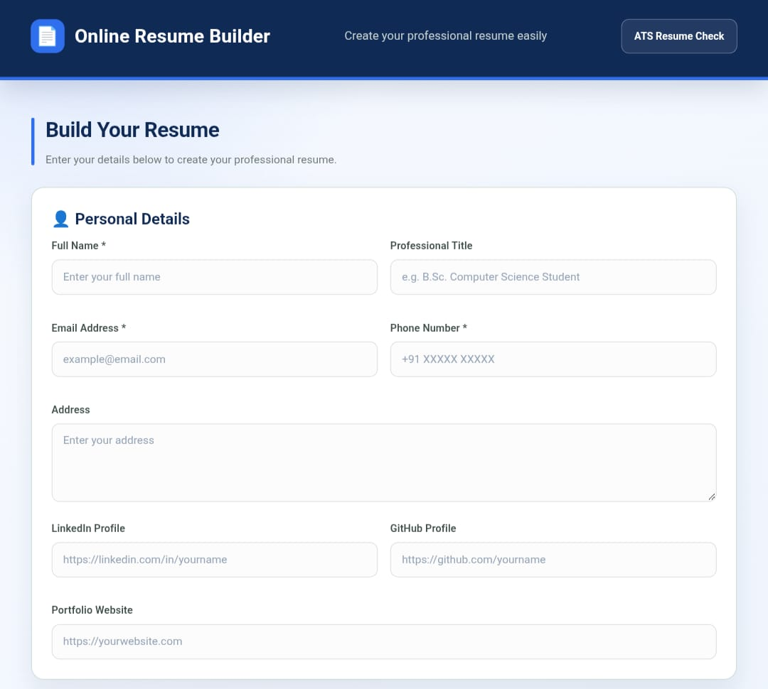

Figure 2: Personal Details Form

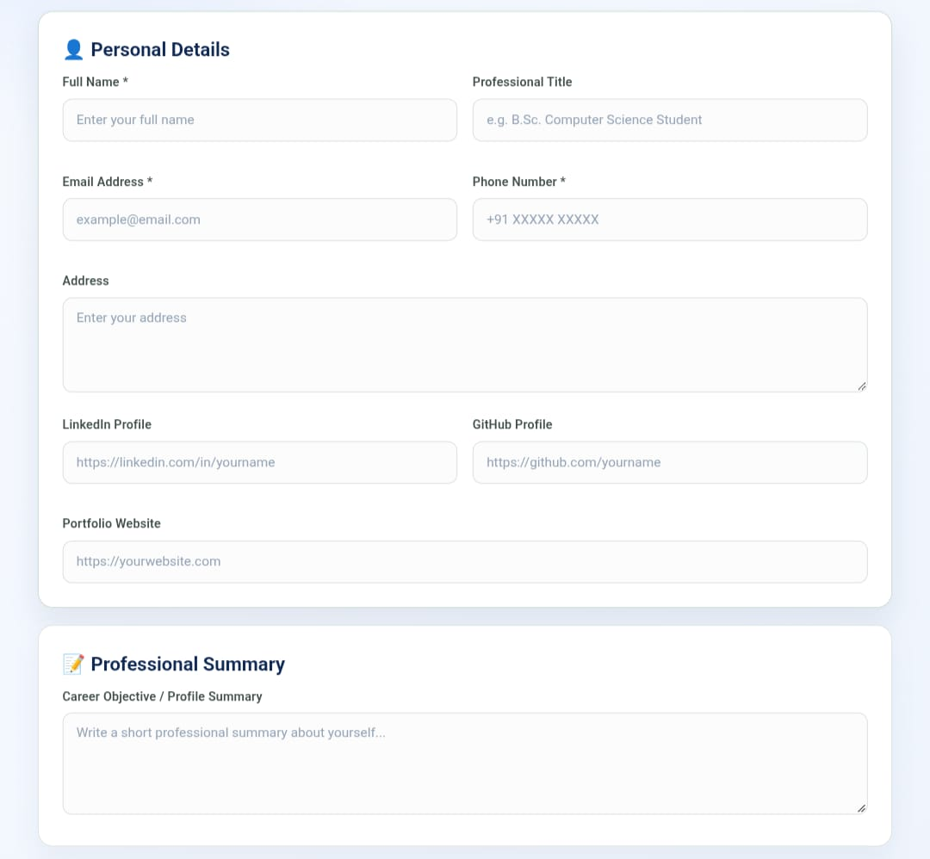

Figure 3: Education Section

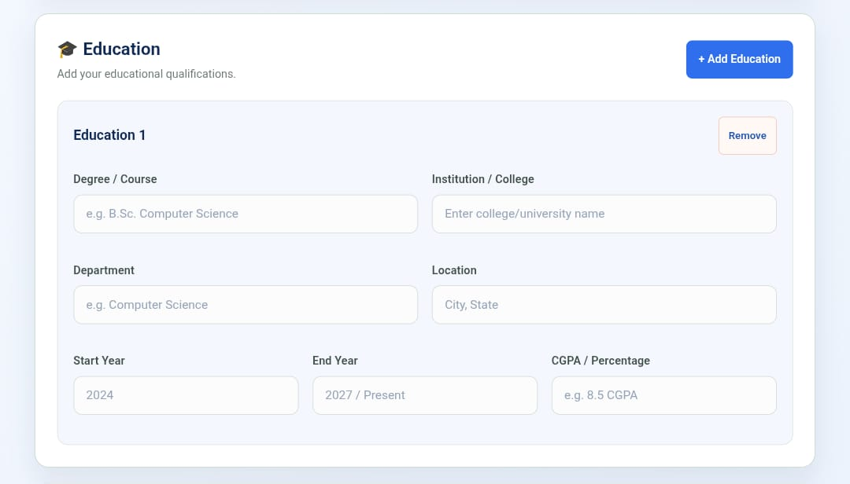

Figure 4: Skills Section

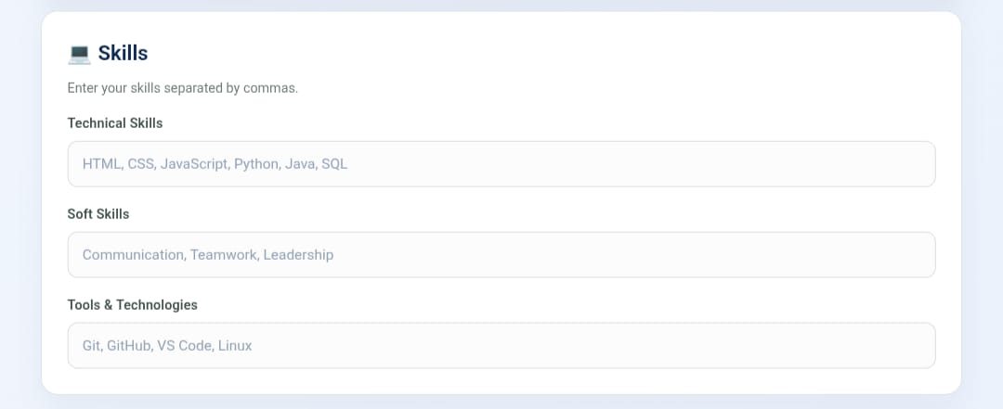

Figure 5: Projects Section

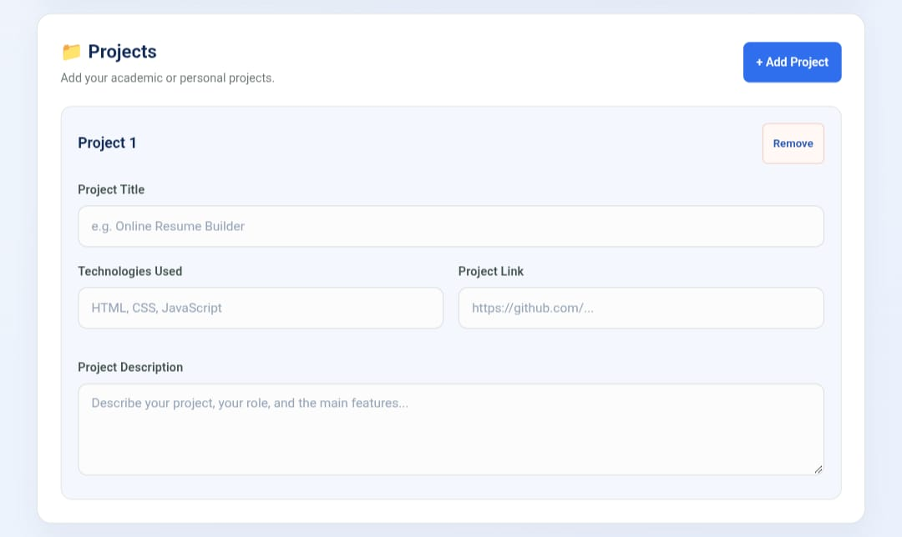

Figure 6: Certifications Section

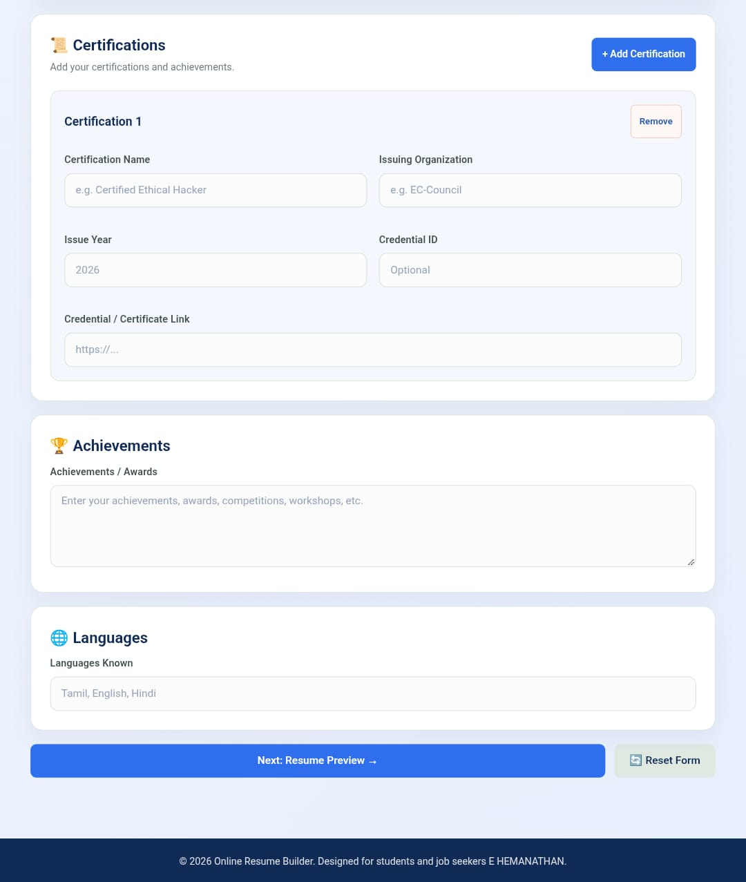

Figure 7: Resume Preview

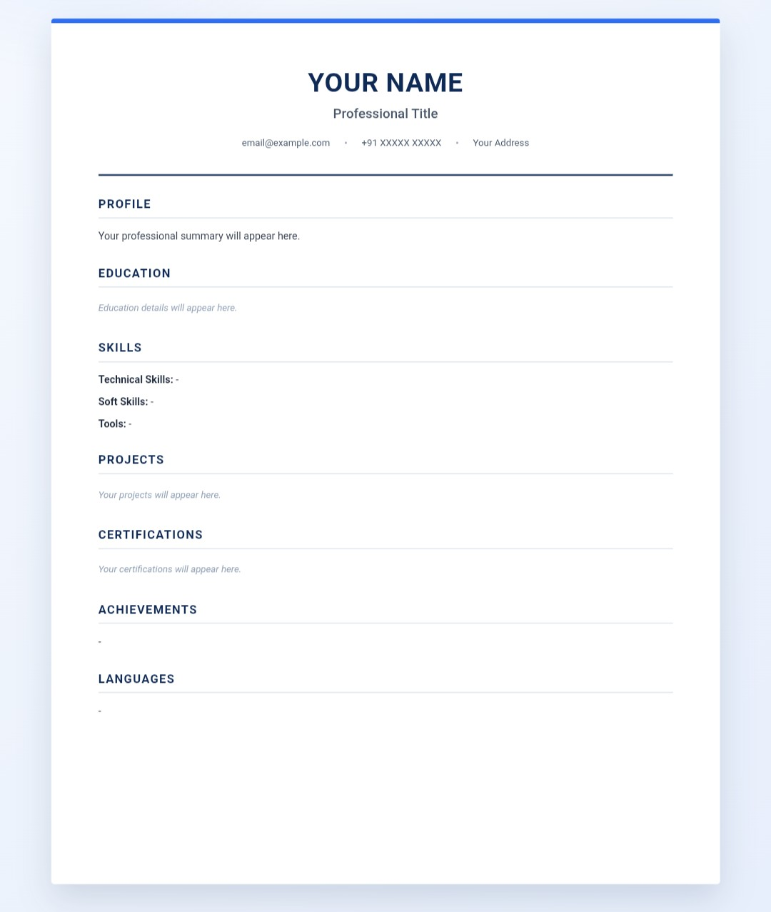

Figure 8: Print / Save PDF

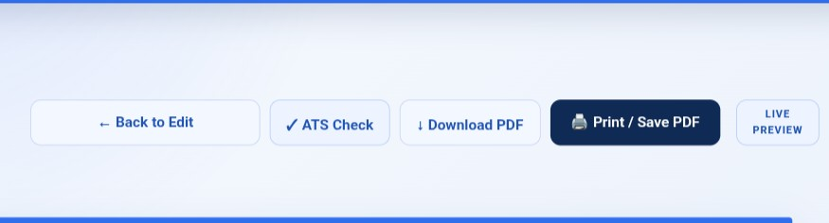

Figure 9: Final Generated Resume

ATS Resume Check:-

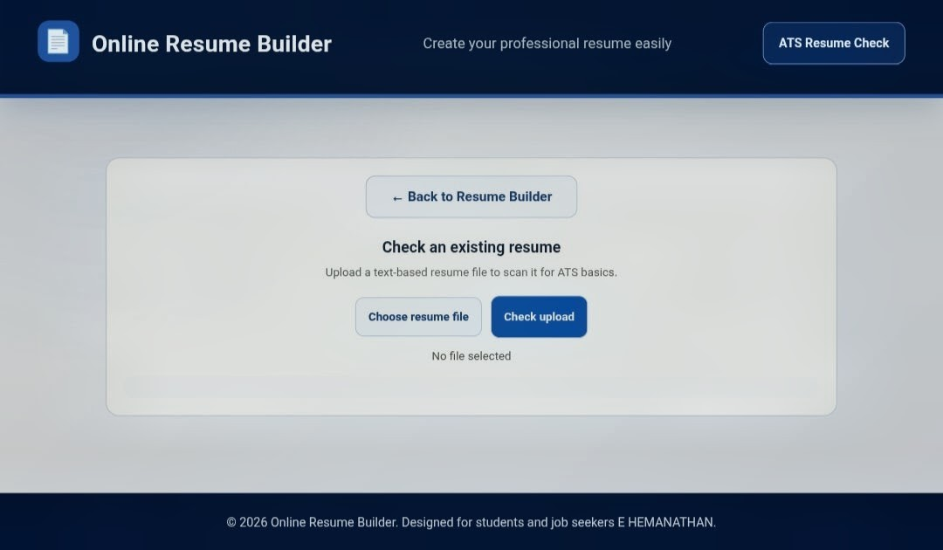



Online Resume Builder project

https://online-resume-builder-beta.vercel.app/

